2018380039_Dikshya Kafle Lab report DBMS

Name: Dikshya Kafle

Student Number: 2018380039

**Experiment 1**

Create and manage database and table

**Goal**

1. Familiar with command line and GUI connection method in MySQL.
2. Master SQL statement to create database and table.
3. Master the update and deletion methods of database and tables.
4. Master the basic methods of backup and restore database.
5. Understand the logical structure and physical structure of MySQL database.

**Content**

1. Use GUI to connect the DBMS
2. Use command line to connect the DBMS
3. Create, backup, drop and restore database and tables through GUI.

* **Database and table**

Database name：SPJ_MNG，four tables in the database：S, P, J, SPJ

S (SNO, SNAME, STATUS, CITY)

P (PNO, PNAME, COLOR, WEIGHT)

J (JNO, JNAME, CITY)

SPJ (SNO, PNO, JNO, QTY)

The supplier table S is composed of supplier code (SNO), supplier name (SNAME), supplier status (STATUS) and supplier city (CITY).

Part list P consists of part code (PNO), part name (PNAME), color (COLOR) and weight (WEIGHT).

Project table J consists of project code (JNO), project name (JNAME) and project city (CITY).

The supply situation table SPJ is composed of supplier code (SNO), part code (PNO), project code (JNO) and supply quantity (QTY). It indicates that the quantity of a certain part supplied by a supplier to an project is QTY.

**S Table**

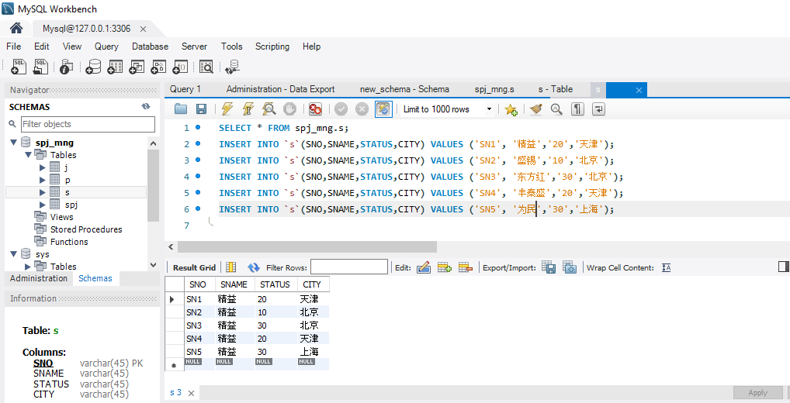

**J Table**

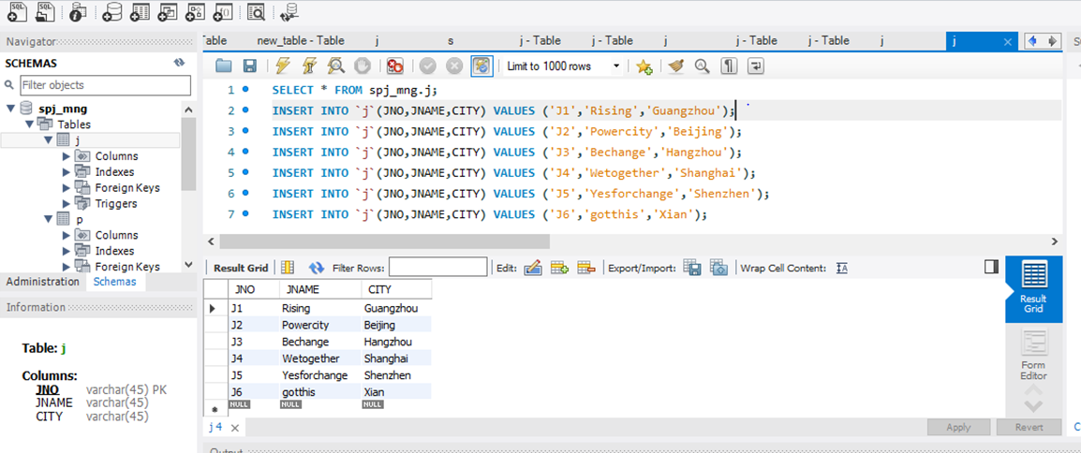

**P Table**

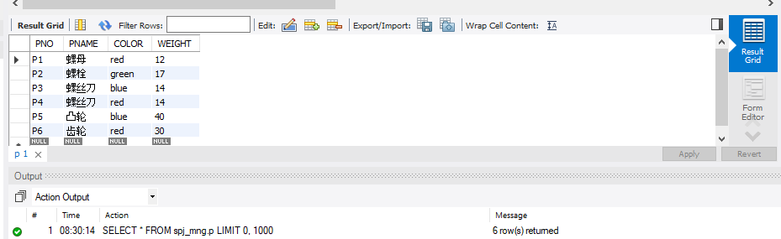

**SPJ Table**

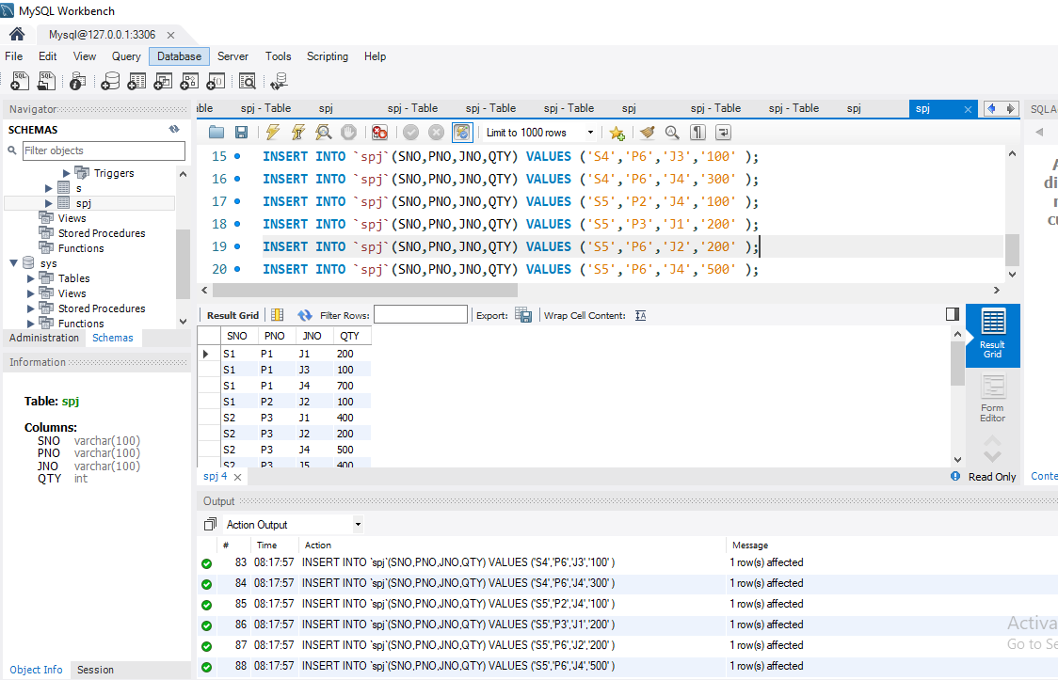

**Restore the database SPJ_MNG with the file you have backed up in previous step**

**Export Database**

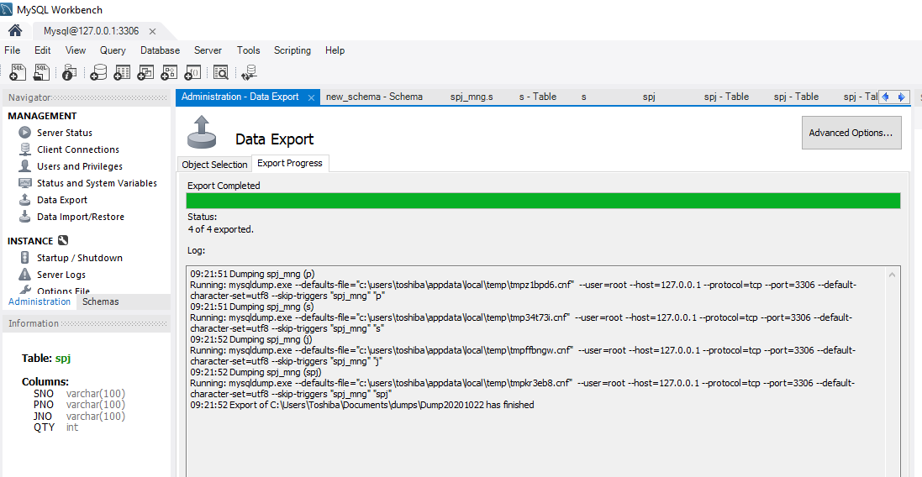

**Import Database:**

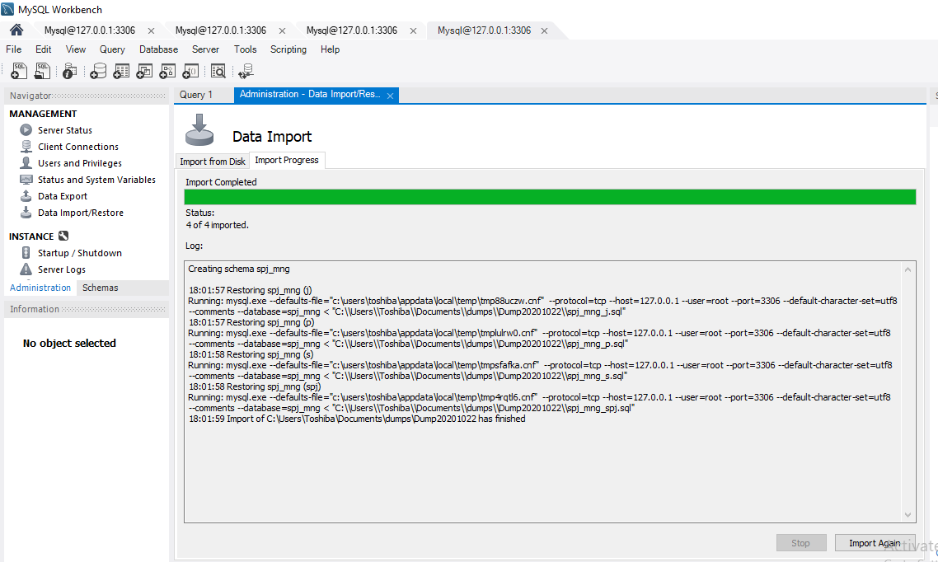

**Imported Tables:**

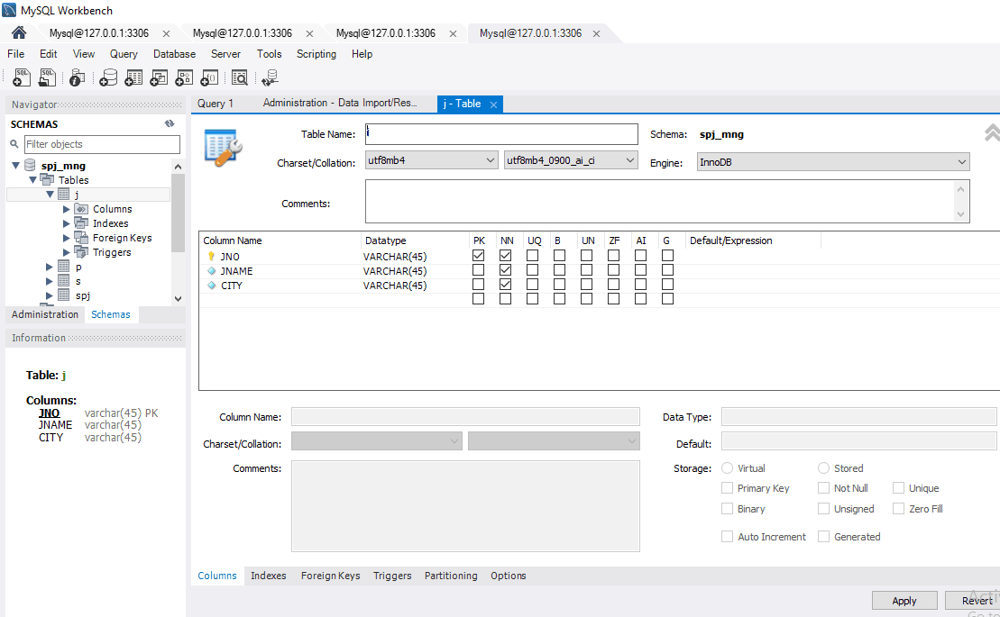

**Restore the database SPJ_MNG with the file have been backed up before**

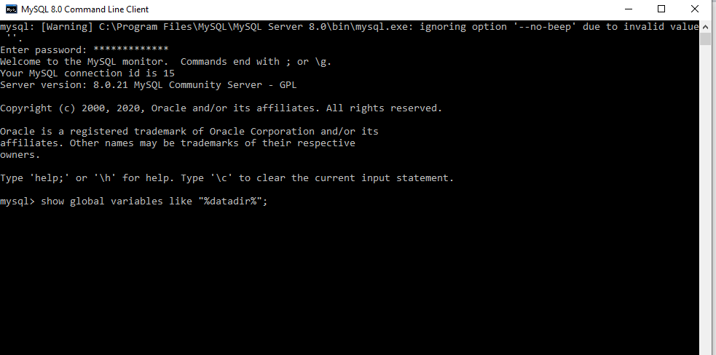

**Updated table S，Add an attribute of contact phone number STEL, the data type is string , and modify the maximum string length allowed by SNO in table S:**

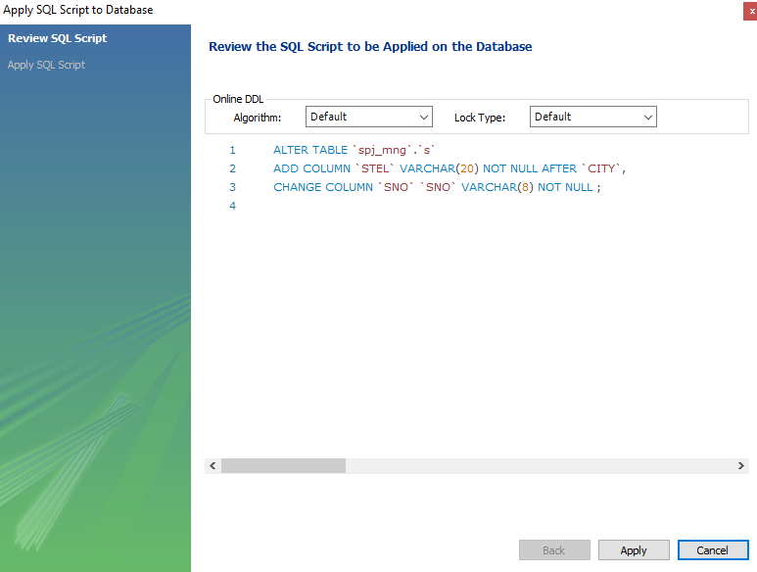

**Understand the physical storage files of MySQL, and check the data files under the local MySQL service installation directory (such as the default installation directory: C: \programdata \ MySQL\ MySQL server 8.0\ data). Try to create tables according to different storage engines of InnoDB and MyISAM, observe and explain the differences of physical storage files.**

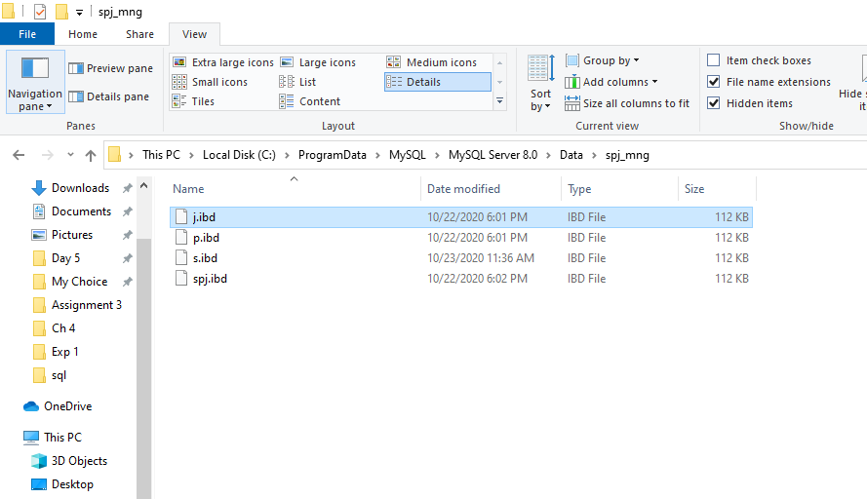

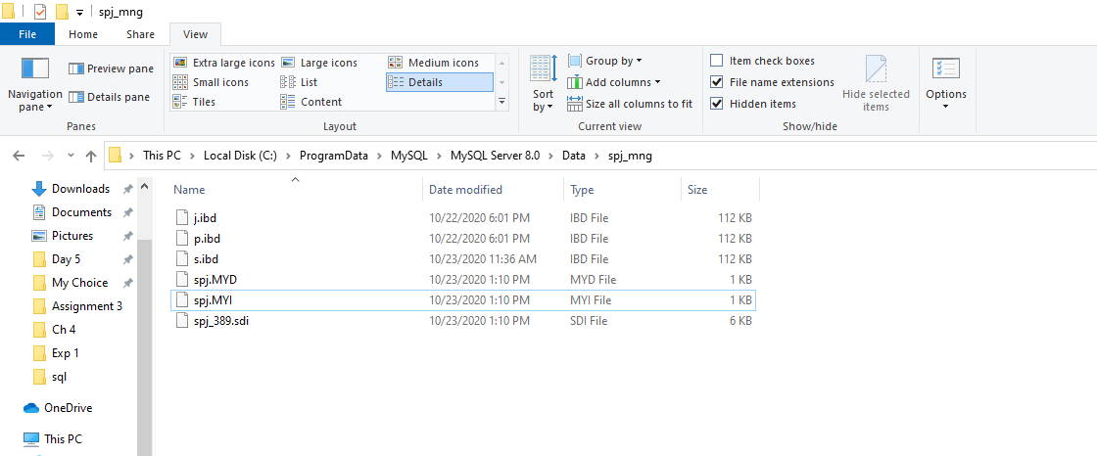

**Create,backup,drop and restore database and table using MySQL command line:**



* Database and tables

Datbase name: university

Tables:

(primary key: red color foreign key: )

Classroom:building, room_number,capacity

Department:dept_name, building, budget

Course:course_id,title,dept_name,credits

Instructor:ID,name,dept_name,salary

Section:course_id,sec_id,semester,year,building,room_number,time_slot_id

Teaches:ID,course_id,sec_id,semester,year

Student:ID,name,dept_name,tot_cred

Takes:ID,course_id,sec_id,semester,year,grade

Advisor:s_ID,i_ID (s_ID references student (ID), i_ID references instructor (ID))

Time_slot: time_slot_id,day,start_hr,start_min,end_hr,end_min

Prereq: course_id, prereq_id

**Use SQL statements to create a database of university.**

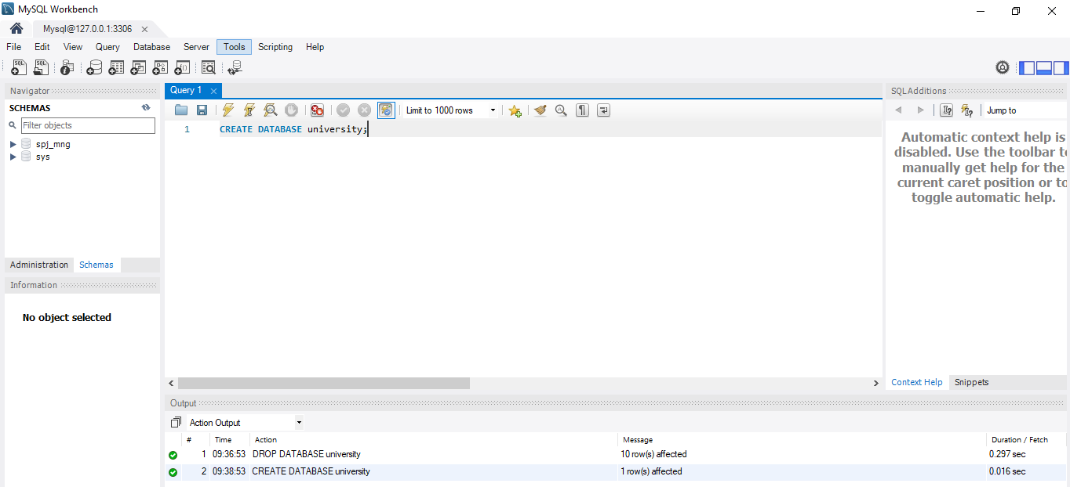

**Use SQL to create 3 tables: student, course, takes, define the data type and primary key, ignore the other constraints, add some tuples if you like.**

**Course Table Created:**

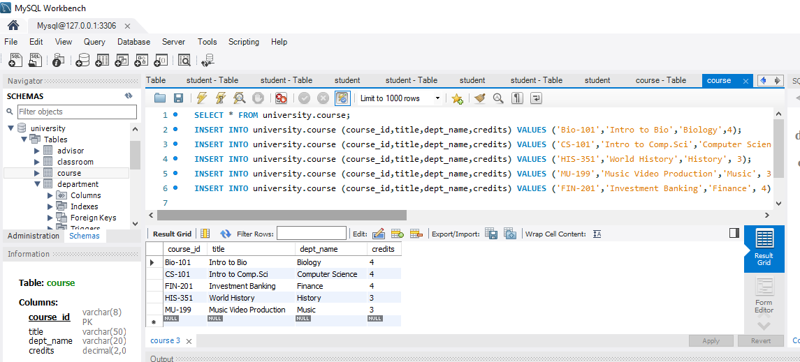

**Student Table Created:**

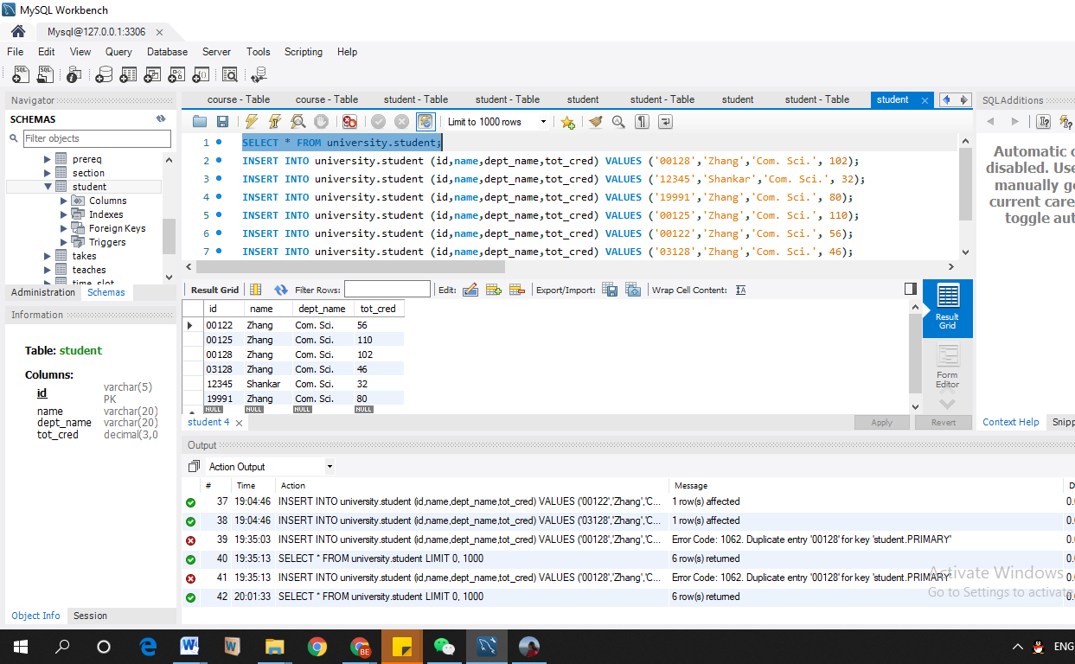

**Takes Table Created:**

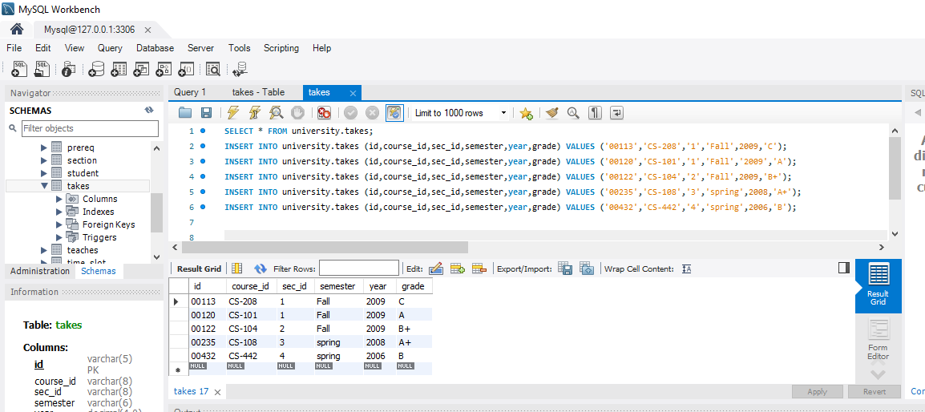

**Backup the database of university.**

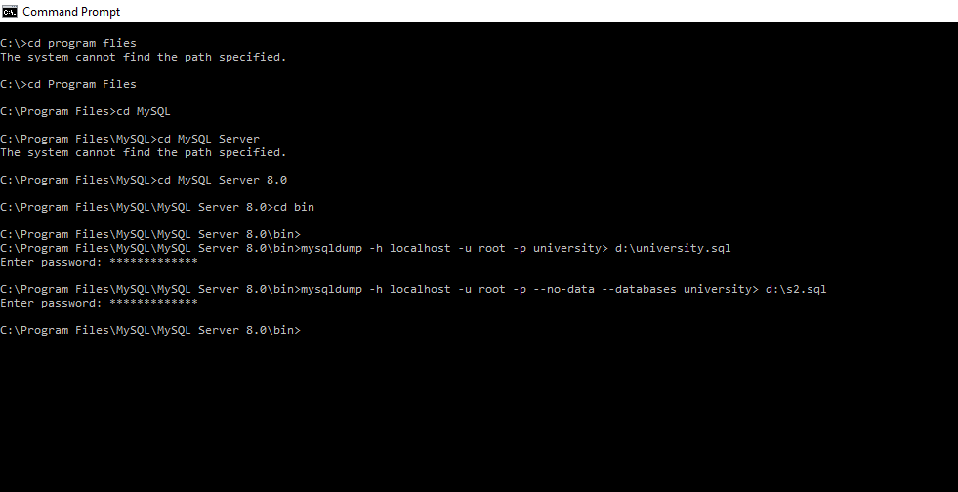

**Delete created tables with SQL statement.**

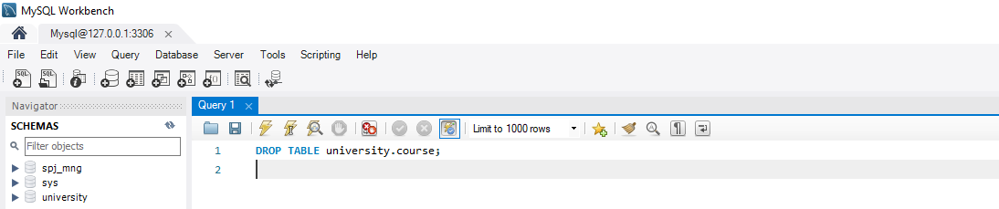



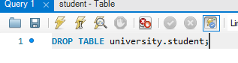

**Delete created database with SQL statement.**

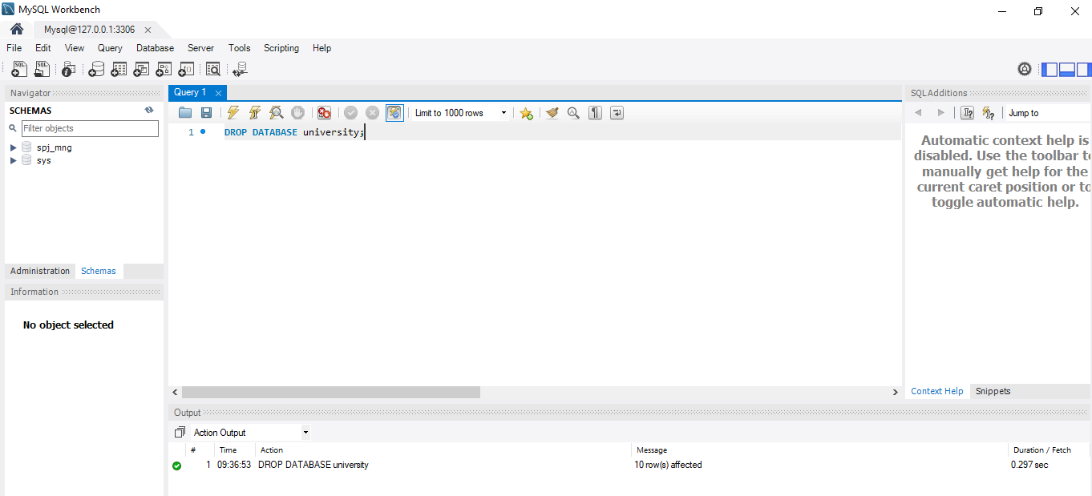

**Restore the database with the backed up files you’ve got in the operation of previous step:**



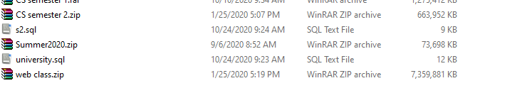

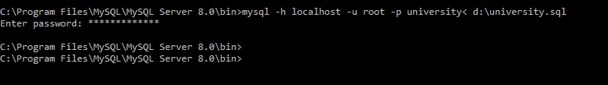

**Use SQL statement to add a new column STEL to store phone number into the table of student**

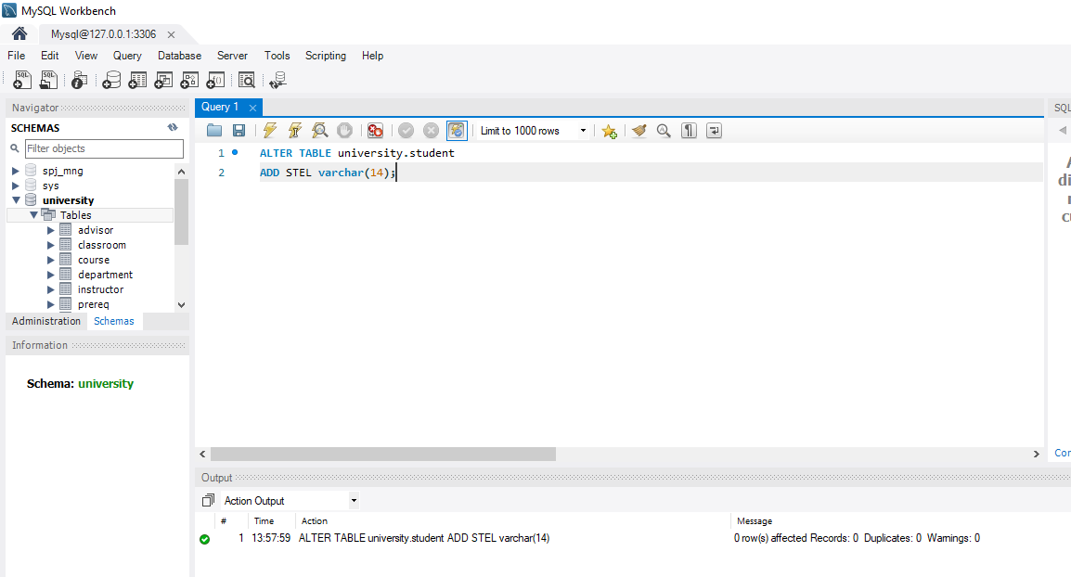

**Modify max length of the attribute id:**

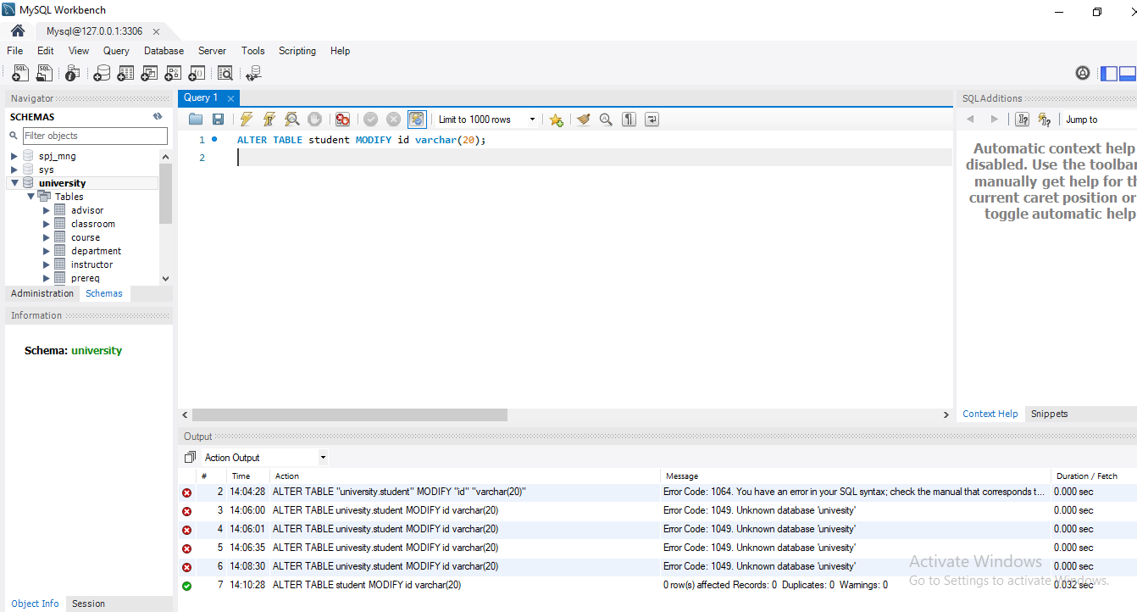

**Check the SQL scripts that define the database or table in the SQL file generated by mysqldump, and compare the similarities and differences between the automatically generated scripts and the SQL statements written by yourself.**

**SQL statement to create student table by me:**

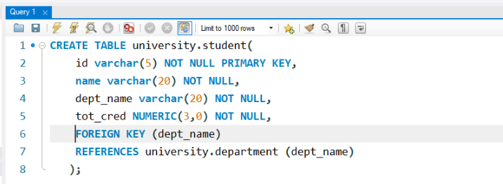

**Auto generated SQL statement for creating student table:**

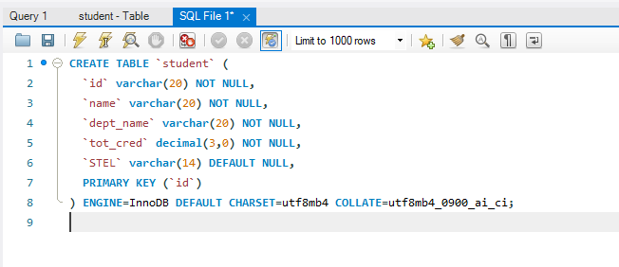

**Comparison of my script vs. the generated script by the system**

* My script only lists the tables and creates attributes and their relation with each other. The generated script consists of more relationships that we are abstract to the users (like null or not null) with more description like Engine, CHARSET, COLLATE. It also has more complex codes difficult to understand on our level.

**Problem:**

Simple minor errors while creating tables caused a lot of hassle. It took a lot of time in creating table. Had some syntax error and it took a little bit of time figure it out. Had problem in using command prompt forgot add the directory file while backing up and restoring the database university.

**Solution:**

To solve these problems I looked for information in internet. In order to understand some questions and procedure I also asked the teacher to help me solve them. And provided instructions helped to solve some of my errors during the experiment.

**Summary:**

From this experiment I have learned SQL statement to create database and table. I have learned how to update and delete methods of database and table. Have become familiar with command line and GUI connection method in MySQL. Similarly, have mastered the basic methods of backup and restore database and understood the logical structure and physical structure of MySQL database.